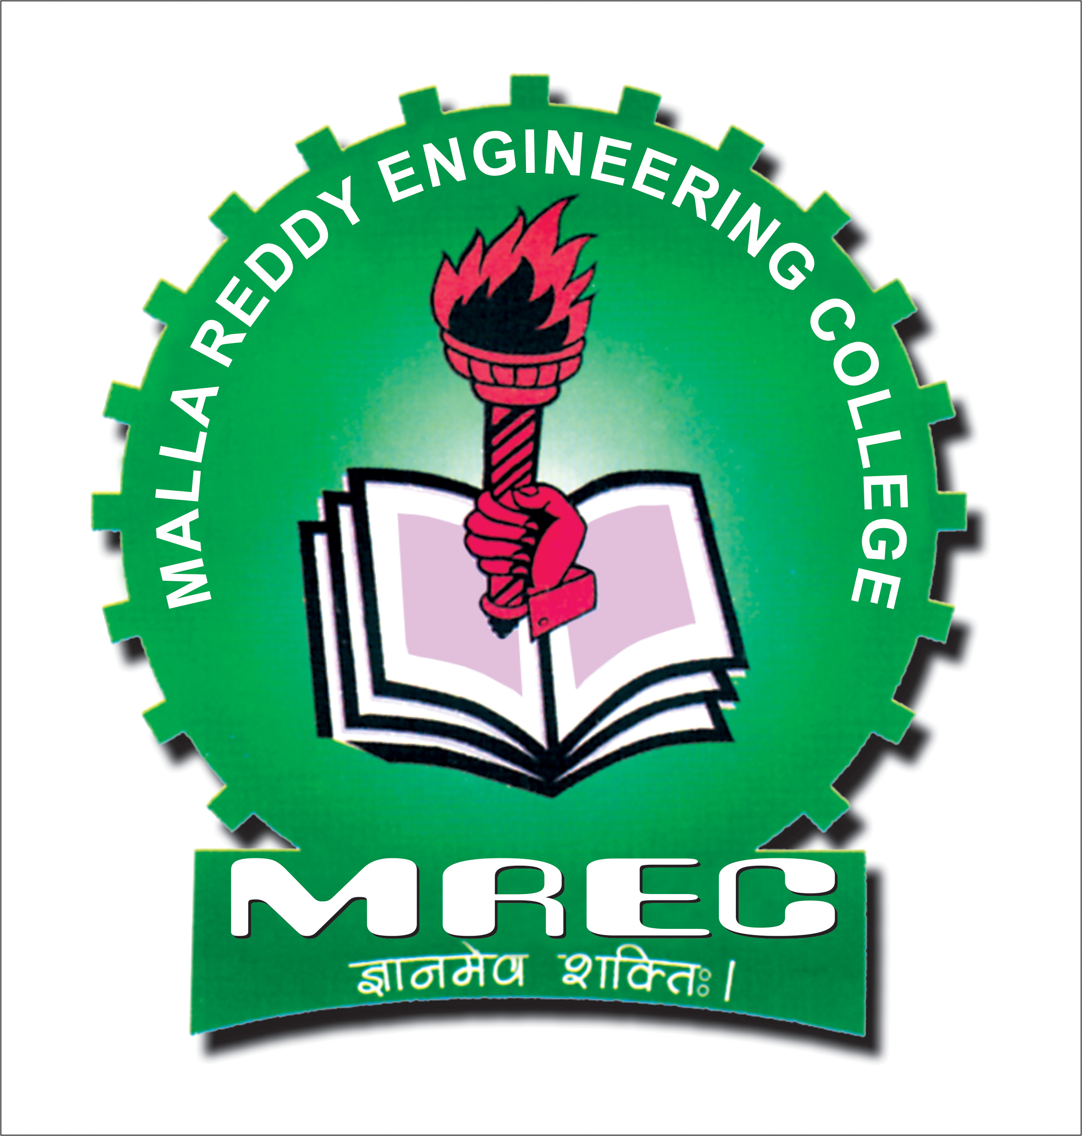
Malla Reddy Engineering College (Autonomous)
Maisammaguda, Dhulapally (Post via Kompally), Secunderabad-500 100.
Department of Information Technology

Minutes of the meeting - UG - B.Tech (IT) Board of Studies

Date: 11.08.2021

The 11th Board of Studies (BoS) meeting for B.Tech (Information Technology) is conducted on 11-00-2021 at 10:00 A.M through online (Zoom) mode.
The following members are attended to the BoS meeting to finalize the II B. Tech (IT) Schema and Syllabus of MR21 Regulations.
S. No | Name of BoS Member | Designation | BoS Position | Mode of Attendance
1 | Dr. M. Deena Babu | Prof. & HOD/ IT | Chairman | Offline
2. | Dr. D. Ramesh | Prof & Head, Dept. of CSE, JNTUH, College of Engineering, jagityal. | University Nominee | Zoom
3 | Dr. M. Swami Das | Professor, Dept. of CSE , CBIT- Hyderabad | Subject Expert | Zoom
4. | Dr. M. Suresh Babu | Professor, CSE Dept., KLU- Hyderabad | Subject Expert | Zoom
5 | Mr. Girish | Co-Founder & CEO, Q-Spiders, Bangalore | Industry Expert | -
6 | Dr. A. Vijendar | Assoc. Professor/CSE | Member | Offline
7 | Mr. G. Satish | Asst. Professor/IT | Member | Offline
8 | Ms. T. Swapna | Asst. Professor/IT | Member | Offline
9 | Ms. P. Swapna | Asst. Professor/IT | Member | Offline
10 | Mr .A. V. Rami Reddy | Asst. Professor/IT | Member | Zoom
11 | Mrs. Rajesjwari Harbeel | Asst. Professor/IT | Member | Zoom

Agenda of the Meeting:

The Agenda of the meeting is as follows.

- Action Taken Report (ATR) on previous BoS Meeting in A.Y 2020-21 held on 05.02.2021.
- Discussion and approval of B. Tech. (IT) MR21 Regulations I and II Years Course Schema and Syllabus.
At the outset, Dr. Deena Babu Mandru, HoD-IT and Chairman-BoS, welcomed the members and outlined the agenda and then briefed about the previous BoS meeting resolutions and Action Taken Report (ATR). After that BoS Members reviewed and discussed the proposed agenda. Finally the Bos members approved resolutions unanimously what are discussed to implement from the academic year 2021-22 and onwards.
.
The following resolutions are approved after careful discussion and observations.
- The BoS Members have thoroughly reviewed and approved the MR21 I & II Year Course Schema and Syllabus, B.Tech. (IT) Course as per AICTE, UGC and JNTUH, Hyderabad. guidelines
The following other suggestions were made by the BoS members and to be implement in MR21 Regulations IT Schema and Syllabus.
Suggestions made by the BoS Members:

The following suggestions were made by the members of the BoS and to be implemented from the next Academic Regulations (i.e. MR21).

- Suggested to change the Object Oriented Programming to Object Oriented Programming through Java in II Year I Semester.
- Suggested that not mention language name while writing program names for Data Structures Lab in II Year I Semester.

Finally, Dr. Deena Babu Mandru, IT Chairman, BoS has expressed his sincere thanks to all the Members of the BoS for their active participation and contribution. The meeting concluded at 12:00 PM.

Dr. Deena Babu Mandru Chairman, IT -BOS

